Programme : DC Jamboree 2003 @ INTERACTION IVREA

Dates: 20-22 November 2003 (18 Nov for Projects Delivery- 19 Nov Exhibition Set up – 23 Nov Exhibition Dismantling – 24 Nov Projects Shipment)
Interaction Design Institute Ivrea
Via Montenavale , 1 - 10015 Ivrea (TO)

Location information: http://www.interaction-ivrea.it/en/about/location/index.asp (select Directions for detailed distances from airports, and IVREA map)

Closest Airport: TORINO airport.
Next closest airport: Malpensa international airport (in the Milan area)

IDII: http://www.interaction-ivrea.it

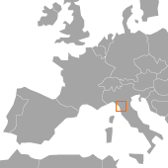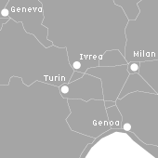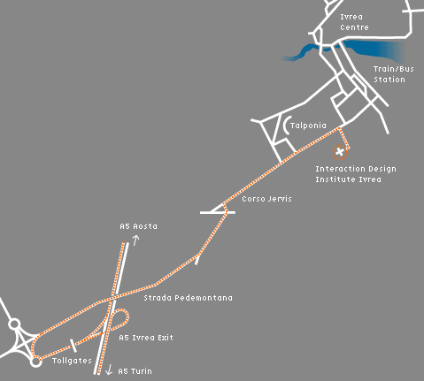

Saturday 22/11/2003
DC Exhibition open day at OFFICINE H exhibition hall (9.00-19.30)
The DC exhibition will be open all day for scientists and press to experience the final results and see demo prototypes of the Disappearing Computer projects.
Registration for visitors is free, and visitors badges will be registered upon entrance.

9:00-9.30 Visitors arrival and registration at OFFICINE H exhibition hall

Plenary session @ OFFICINE H auditorium:
9:30 - 11:00 Evaluation and Impact Assessment of the Disappearing Computer initiative, panel discussion (DC-SG, FET-DC Project Officers, Review panel, DC projects)
11.00-11.30 Coffee break, or visit the DC demos exhibition
11.30 -13.00 Invited Speakers
11.30: Kieran Delanay, National Microelectronics Research Center, Ireland: Miniaturization and sensor issues.
12.00: John Bowers KTH, Sweden. (Title to be confirmed).
12.30: Jean Schmitt, SOFINNOVA PARTNERS: Venture Capital funding as one route to exploitation of DC results.
      - Light Buffet lunch (external visitors may have to pay for lunch coupon), OFFICINE H auditorium / visit the DC demos exhibition
Parallel Workshop Sessions (@Interaction Ivrea Blue Building):
14.30- 16.30 3 parallel half-day workshops part A (at Interaction Ivrea blue building)
Workshop A. Venture Capital workshop (organized by G. Pogorel, Prof. Ecole Nationale Supérieure des Télécommunications, Paris, J. Schmitt, SOFINNOVA PARTNERS, Paris).
Workshop B. Facing the privacy issues: Privacy Guidelines for DC (organized by Saadi Lahlou, Laboratory of Design for Cognition, EDF R&D, Paris, François Jegou, Dàlt Brussels & Politecnico di Milano Marc Langheinrich, ETH Zürich)
Workshop C. Attention Control Architectures for Ambient Intelligence. (organized by Prof. John G. Taylor, & Dr. Stathis Kasderidis, King’s College London, Dr. Nikolas Tsapatsoulis, National Technical University of Athens).
16.30- 18.30 3 parallel half-day workshops part B (continued) (at Interaction Ivrea blue building)
Plenary Session @ OFFICINE H auditorium:
19.00 - 19.30 Closing speech of the DC Jamboree 2003 – Norbert Streitz & Paddy Nixon
19.30 Farewell Aperitifs, for the DC-net members

